CMPG 311 PROJECT
SHOPSMART SYSTEM (Integrated Product and Service E-commerce Platform)
GROUP INFORMATION
MASHAO BB 45408173(Group Leader)
RAMONYAI MG 40736636
TAWANA KQ 29290473
KOBE LT 45532206
DIMBA S 42279682
DIRA TB 45600244
MABE G 41408934
SANGWENI MC 54157722

Table of Contents
1.Conceptual Design
1.1 Business Rules
1.2 ER Diagram
1.3 Relationships Between Our Tables Description
1.4 Derived Attributes
1.5 Normalization Description
2. Logical Data Model

1.CONCEPTUAL DESIGN
1.1 Business Rules
The following business rules were extracted directly from the ShopSmart System operational requirements outlined in Phase 1. Each rule reflects a real-world constraint that the database and application logic must enforce to maintain data integrity, platform trust, and consistent user experience.
No. | Business Rule | Description
1 | A student must register before accessing the platform | Every user must have a unique account to browse listings, place orders or book services. Anonymous access is not permitted
2 | A vendor must be verified before listing products or services | To maintain trust and quality on the platform, vendors require admin approval before their listings become visible.
3 | A student(customer) may place one or more orders | A single student can generate multiple orders overtime. Each order belongs to exactly one student.
4 | An order must contain at least one product or service | An empty order is logically invalid. Every order references at least one order line item.
5 | A product or service must belong to exactly one vendor | Each listing is owned and managed by a single vendor to establish clear accountability
6 | A delivery record is created for every completed product order | Physical goods require delivery tracking; service bookings do not generate a delivery record
7 | A customer may submit at most one review per order | To prevent duplicate or spam reviews, each order may only attract one review from the purchasing student.
8 | Payment must be recorded before an order is marked as confirmed | An order transitions to confirmed status only after a payment record has been successfully created.
9 | Delivery is restricted to on-campus and nearby off-campus student residences | As defined in the project scope, nationwide delivery falls outside system boundaries.
10 | An administrator manages system users and can deactivate any account | Role-based access control grants the admin authority to suspend vendors or students who violate platform rules.

1.2 ER Diagram
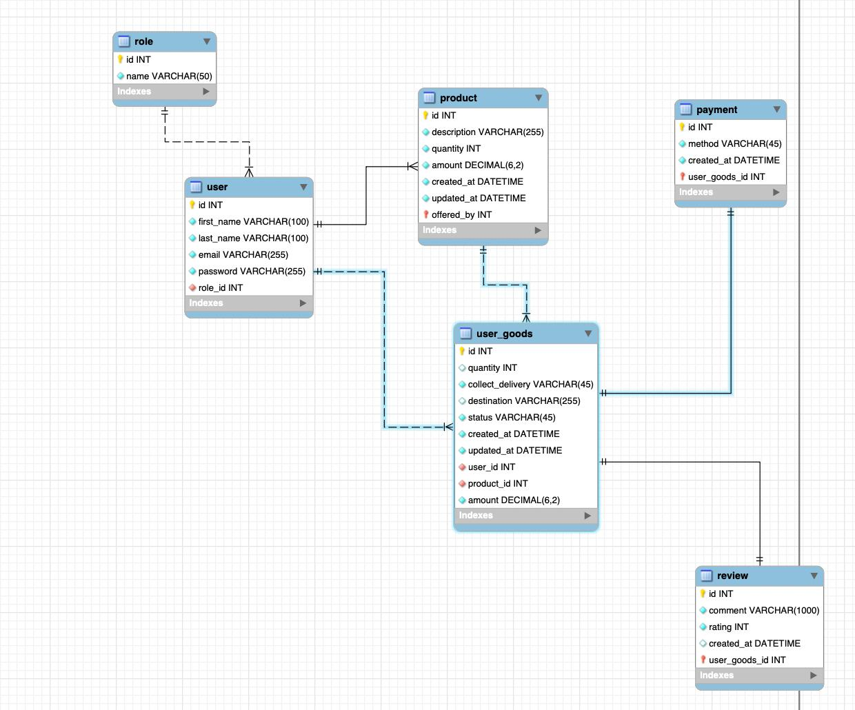

1.3 Relationships Between Our Tables Description

1. User ↔ Product (Vendor role)
One-to-Many (1:M)
- A user (vendor) can list multiple products.
- Each product belongs to one user.
- Participation:
  - Product → Total
  - User → Partial
2. User ↔ Service (Vendor role)
- One-to-Many(1:M)
- A user can offer multiple services.
- Each service belongs to one user.
- Participation:
  - Service→ Total
  - User → Partial
3. User ↔ Order (Customer role)
- One-to-Many (1:M)
- A user (customer) can place multiple orders.
- Each order belongs to one user.
- Participation:
  - Order → Total
  - User→ Partial
4. Order↔ Product
- Many-to-Many (M:M)
- An order can contain multiple products.
- A product can appear in multiple orders.
Implemented using Order Details (bridge entity)
5. User ↔ Reservation
- One-to-Many (1:M)
- A user can make multiple reservations.
Each reservation belongs to one user.
6. Service ↔ Reservation
- One-to-Many (1:M)
- A service can have multiple reservations.
- Each reservation is linked to one service.
7. Order ↔ Payment
- One-to-One (1:1)
- Each order has one payment.
- Each payment is linked to one order.
8. User ↔ Review
- One-to-Many (1:M)
- A user can write multiple reviews.
- Each review belongs to one user.
9. Product ↔ Review
- One-to-Many (1:M)
- A product can have multiple reviews.
10. Service ↔ Review
- One-to-Many (1:M)
A service can have multiple reviews
Weak Entity
Order Details is a weak entity because it depends on both Order and Product for its existence.
1.4 Derived Attributes
- Order Total:
Derived from the sum of (product price × quantity) in Order Details.
- Average Rating:
Derived from all ratings given to a specific product or service.
- Total Orders per User:
Derived from counting the number of orders placed by a user.
1.5 Normalization Description
First Normal Form (1NF)
- All attributes are atomic so each field contains only a single value.
- There are no repeating groups.
Second Normal Form (2NF)
- There is no partial dependency.
- All non-key attributes depend on full primary key.
Third Normal Form (3NF)
- There are no transitive dependencies.
- All attributes depend only on primary keys.
2. LOGICAL DATA MODEL
